AUDIT

DEFENSE

Never face the IRS alone.

What if you get audited?
Getting contacted by the IRS is a nerve-wracking experience, especially if it’s a notification that you’re being audited. While there are things that increase your chance of being audited (such as being self-employed or making an error on your tax return), it can happen to anyone. There’s no way to guarantee you won’t be. Consider this:

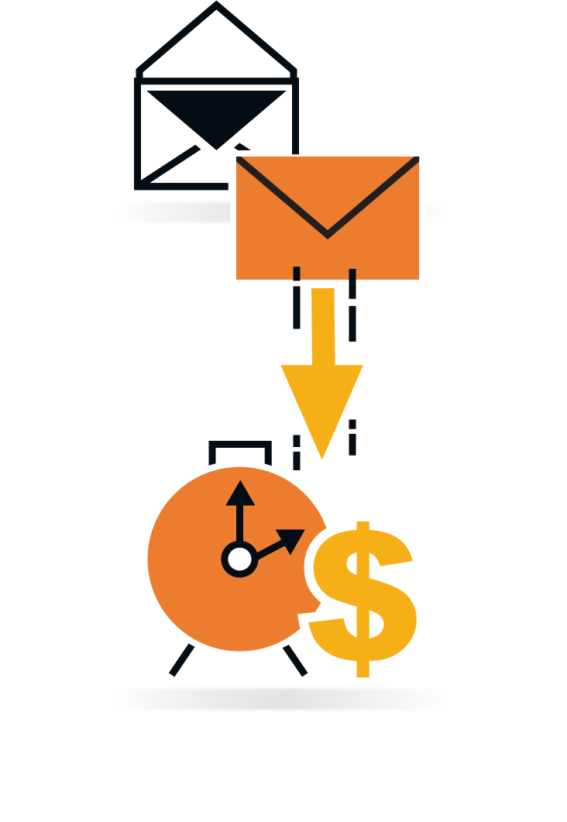

The IRS sends out more than 200 million notices and letters each year, and they’re getting even more efficient. That adds up to a pretty fair chance of getting contacted by the IRS at one point or another, and if you do, we want to help you handle it.

The average response to an IRS notice takes a tax professional 3-5 hours. At $150 to $400 per hour, that simple letter from the IRS could cost you $450 to $2,000. Without the guidance of a tax professional, small problems can quickly turn into really big problems.

m

How we can help
You don’t have to face the IRS alone. We now provide audit defense to our clients. For a small, annual fee, we’ll handle your IRS correspondence and representation if you’re audited. You won’t have to deal with any of the things that make an audit so stressful—no talking with the IRS on the phone or in-person, no waiting on hold, and no deciphering your tax documents—we’ve got you covered.
Because we have allocated resources and acquired tools to offer this program, we are able to deliver more value to you at a fraction of what it would normally cost. Usually, our representation services cost 400/hour during tax season and 150/hour outside of tax season, but under our new plan, you will pay less than half of that. Additionally, we’re offering our plan at three different tiers, so you can choose the amount of defense that’s right for you and your tax situation. Our biggest priority is giving you peace of mind that your audit is being handled in the best way possible (with the least amount of interruption to your life.)

Tiers to choose from

$40 per year

Tier 1

Tier 2

$90 per year

- Review IRS/state correspondence and give you a recommendation on action you can take on your own. Essentially this is explaining the notice to you and providing you with some direction. This tier does not include representing you.

- Review IRS/state correspondence.
- Represent you to resolve the issue with the IRS or State (form 2848 limited power of attorney required).
- Limited to 2 hours of representation work ($300 to $800 value depending on time of year)
- Includes 30 min of consultation time for other unrelated matters (phone, email, in-person)

Tier 3

$150 per year

- Review IRS/state correspondence.
- Represent you to resolve the issue with the IRS or State (form 2848 limited power of attorney required).
- Limited to 4 hours of representation work ($600 to $1,200 value depending on time of year)
- Includes 1 hours of consultation time for other general tax issues (phone, email, in-person)

I elect to enroll in Wichita Tax Advisor’s Audit Defense plan, Tier (1, 2, or 3) ______ for Tax Year 2021.

_____________________________________________ _______________________
Signature Date

FAQs

Do I have to enroll in audit defense?
Absolutely not, but it’s the easiest (and most cost effective) way to make sure you’re covered in the case of an audit.

Which tax returns are eligible for audit defense?
Form 1040, Individual Amended, late, and extended individual tax returns are also eligible.
Corporation and partnership returns (Form 1120, 1120S, and 1065) are not eligible.

What kind of IRS issues does this plan cover?
This plan is for IRS-initiated action related to errors in reporting income, selection of audit, etc. You will not be subject to IRS issues that arise from an error made on our end.

What should I do if I receive an audit notice from the IRS?
Call us right away so we can start resolving your issue.

Can I cancel my plan?
You may cancel your plan within 30 days of filing your tax return for any reason.

Can I purchase defense for past tax returns?
Audit defense is limited to the current tax year when the plan is charged only.

